I2C Controller

Version 1.0

SHMT Co., Ltd.

REVISION HISTORY
Version | Detail(굴림/Verdana 10pt bold) | Name | Date
1.0 |  | Duck | 2006/12/13

Technical documents
Copyright © 2006 Shmt Limited. All rights reserved.

Confidentiality Status
This document is NOT OPEN ACCESS. The distribution is restricted to certified company.
This document is CONFIDENTIAL.

Feedback on this document
If you have any comments on this document, please contact your channel to our company.

Shmt Web address
http://www.shmt.com

Contents

Detail contents
1. I2C BUS 7
2. I2C Controller 8
2.1. Overview 8
2.1.1. Feature 8
2.1.2. Block Diagram 8
2.2. Operation 8
2.2.1. Overview 8
2.2.2. Timing 8
2.3. Signal Description 9
2.3.1. APB Signal 9
2.3.2. I2C BUS Signal 9
2.4. Register Description 10
2.4.1. Registers 10
2.4.2. ICCR (I2C Control Register) Register 10
2.4.3. ICSR (I2C Control/Status Register) Register 11
2.4.4. IAR (Slave Address Register) Register 11
2.4.5. IDSR (Data Register) Register 12
2.4.6. ICCR (I2C Clock Control Register) Register 12

Figures

Figure 2-1 I2C Controller Block Diagram 8
Figure 2-2 ICCR0 (I2C Control Register) Register Bits 10
Figure 2-3 ICSR (I2C Control/Status Register) Register Bits 11
Figure 2-4 IAR(Slave Address Register) Register Bits 11
Figure 2-4 IDSR (Data Register) Register Bits 12
Figure 2-4 ICCR1(I2C Clock Control Register) Register Bits 12

Tables

Table 2-1 APB Signal 9
Table 2-2 I2C BUS Signal 9
Table 2-4 Registers(Base Address : ???? ????h) 9
Table 2-5 ICCR (I2C Control Register) Register Description (Offset : 0000 0000h) 10
Table 2-6 ICSR (I2C Control/Status Register) Register Description (Offset : 0000 0004h) 11
Table 2-7 IAR (Slave Address Register) Register Description(Offset : 0000 0008h) 12
Table 2-7 IDSR (Data Register) Register Description(Offset : 0000 0008h) 12
Table 2-7 ICCR (I2C Clock Control Register) Register Description(Offset : 0000 0008h) 12

I2C BUS

Overview

I2C 버스는 Serial Data Line(SDA)와 Serial Clock Line(SCL)으로 구성되어 있다.
이 I2C 버스를 통해 Bus Master와 Peripheral 간의 정보를 교환할 수 있다.

Feature

I2C 버스의 특징은 다음과 같다.
SDA와 SCL로 구성된 2개의 line만으로 구성
Address Decoder 및 기타 Glue logic 불필요
Master는 Master Tx와 Rx 모드로 동작하며 버스 내의 각 device마다 유일한 Address를 갖는다.

I2C Controller

Overview

Feature

- APB Interface
- Master Mode and Slave Mode Support
- High Speed Mode Not Support

Block Diagram

Figure 2-1 I2C Controller Block Diagram
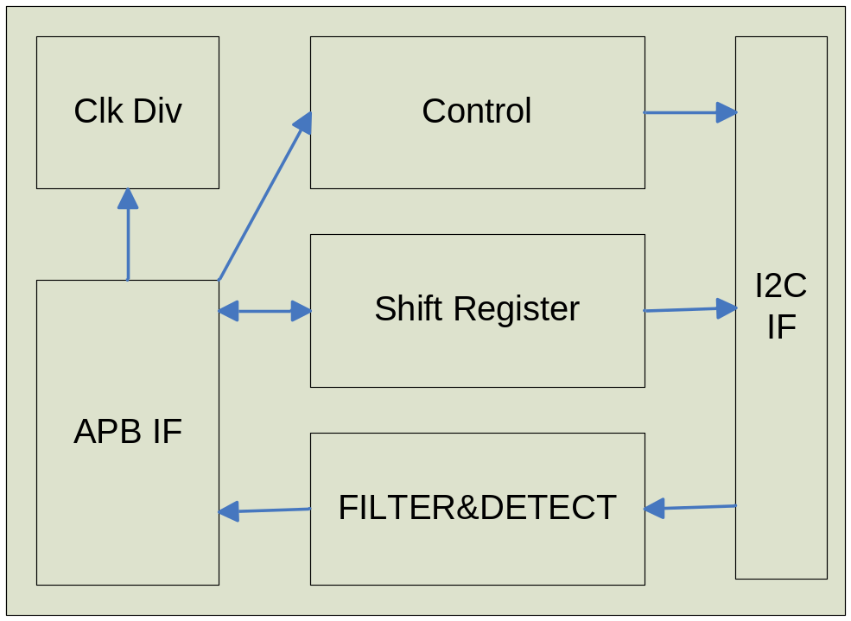

Operation

Overview

APB BUS를 사용하고 있으며 Master Tx/Rx Mode 및 Slave Tx/Rx Mode를 지원한다.

Signal Description

APB Signal

Table 2-1 APB Signal
Signal Name | Direction | Description | Init. value
PCLK | Input | APB Clock
PRESETn | Input | APB Reset
PSEL | Input | APB PSEL
PENABLE | Input | APB PENABLE
PWRITE | Input | APB READ/WRITE
PWDATA | Input | APB Write Data
PRDATA | Input | APB Read Data

I2C BUS Signal

Table 2-2 I2C BUS Signal
Signal Name | Direction | Description | Init. Value
SDA | InOut | PSRAM Chip Select
SCL | InOut | PSRAM Sleep Mode Select

I2C Interrupt Source Signal

Table 2-3 I2C BUS Signal
Signal Name | Direction | Description | Init. Value
I2C_AAS | Out | I2C Address as Slave Interrupt Source  slave모드로 동작할 경우 address가 match 되었을 때 발생하는 interrupt | 0
I2C_INT | Out | I2C interrupt  I2C 동작 도중 발생하는 interrupt (Start/Stop Arbitration lost 등) | 0

Register Description

Registers

Table 2-4 Registers(Base Address : ???? ????h)
Offset | Name | R/W | Description | Init. Value
0000h | ICCR0 | RW | I2C Control register | 0000 0000h
0004h | ICSR. | RW | I2C Control/Status register | FFFF FFFFh
0008h | IAR | RW | I2C Slave Address register | 0000 0000h
000Ch | IDSR | RW | I2C Data Register
0010h | ICCR1 | RW | I2C Clock Control Register

ICCR0 (I2C Control Register) Register

Figure 2-2 ICCR0 (I2C Control Register) Register Bits
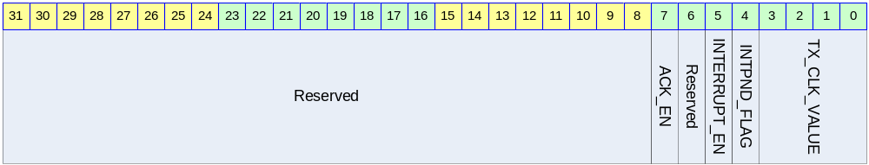

Table 2-5 ICCR0 (I2C Control Register) Register Description (Offset : 0000 0000h)
Bits | Name | R/W | Description | Init. Value
[7] | ACK_EN | RW | ACK Transmit  1: ACK를 전송  0: NACK를 전송 | 0b
[5] | INTERRUPT_EN | RW | Interrupt Enable  1: Enable (interrupt 발생)  0: Disable (interrupt 발생하지 않음) | 0b
[4] | INTPND_FLAG | RW | Interrupt Pending  1: Interrupt Pending (Read)  0: Interrupt Pending Clear (Write) | 0b
[3:0] | TX_CLK_VALUE | RW | Clock Prescaler | 0b

ICSR (I2C Control/Status Register) Register

Figure 2-3 ICSR (I2C Control/Status Register) Register Bits
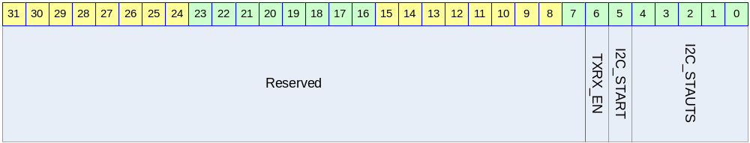

Table 2-6 ICSR (I2C Control/Status Register) Register Description (Offset : 0000 0004h)
Bits | Name | R/W | Description | Init. Value
[6] | TXRX_EN | R/W | I2C TX/RX Enable | 0
[5] | I2C_START | W | 1: START 전송  0: STOP 전송
[4:0] | I2C_STATUS | R | I2C State Code | 0000

IAR (Slave Address Register) Register

Figure 2-4 IAR(Slave Address Register) Register Bits
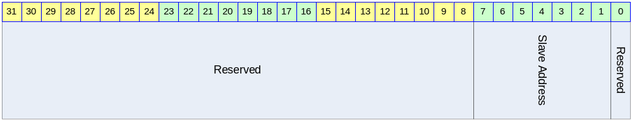

Table 2-7 IAR (Slave Address Register) Register Description(Offset : 0000 0008h)
Bits | Name | R/W | Description | Init. Value
[7:1] | SlaveAddress | RW | 7Bit Slave Address | 1111111b

IDSR (Data Register) Register

Figure 2-5 IDSR (Data Register) Register Bits
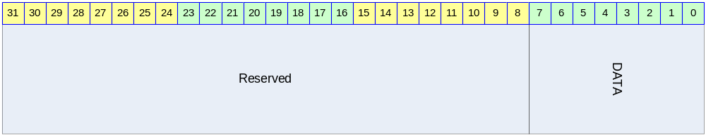

Table 2-8 IDSR (Data Register) Register Description(Offset : 0000 0008h)
Bits | Name | R/W | Description | Init. Value
[7:0] | DATA | RW | DATA In-Out Register | 11111111b

ICCR1 (I2C Clock Control Register) Register

Figure 2-6 ICCR1(I2C Clock Control Register) Register Bits
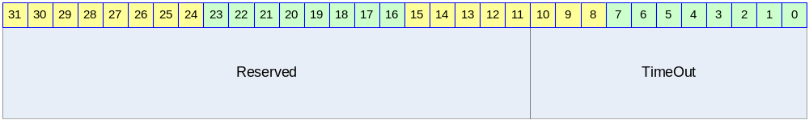

Table 2-9 ICCR (I2C Clock Control Register) Register Description(Offset : 0000 0008h)
Bits | Name | R/W | Description | Init. Value
[5:0] | ICCR1 | RW | Clock Divider setting value | 111111b

Operation Sequence

Master Tx/Rx

- Prescaler를 설정
- Interrupt를 enable로 설정
- ICSR의 TXRX_EN bit를 1로 하여 전송이 가능하게 만든다.
- Start 전송을 위해서 I2C_START bit를 1로 써넣으면 Start가 되면서 interrupt가 발생한다.
- Interrupt Pending Bit가 1인 상태에서 IDSR 레지스터에 값을 써넣고, Interrupt Pending Bit를 clear하면 IDSR 레지스터에 쓰여진 값이 SDA라인을 통해 전송이 된다.
- 위에 전송에서 R/W bit에 따라 다음 전송이 Tx인지 Rx인지가 정해진다.
- IDSR 레지스터의 값이 모두 전송되면 또 다시 인터럽트가 발생하고 이때 데이터를 계속 날릴 것인지 Stop을 보낼 것인지에 따라 다르게 세팅을 해주면 된다.
- 주의 할 점은 interrupt pending 상황에서 setting을 하고 interrupt pending bit를 clear해야 된다는 점이다.

